1. Suppose Anabil produces two outputs: motorbikes & autorickshaw. The table lists some combinations of the quantities of motorbikes and autorickshaws that can be produced in a month given the resources available:

|  |  |
| --- | --- |
| Number of Motorbikes | Number of Autorickshaws |
| 20 | 0 |
| 15 | 1 |
| 10 | 2 |
| 5 | 3 |
| 0 | 4 |

1. Draw Anabil’s PPF of motorbike and autorickshaw using the combinations in the table above.

Ans. Plot the points and draw.

1. Calculate Anabil’s opportunity cost when he increases his production of autorickshaw from 0 to 2.

Ans. Opportunity cost of increasing from 0 to 2 units of autorickshaws is 10 units of motorbikes.

1. If Anabil wants to increase the production of autorickshaw from 2 units to 4 units, how many units of motorbikes does he need to give up?

Ans. When Anabil increases autorickshaw production from 2 to 4, his opportunity cost is 10 units of motorbikes. He is losing 10 units of motorbikes to gain 2 more units of autorickshaw.

1. Does Anabil’s PPF exhibit increasing, decreasing, or constant opportunity costs (circle one)? Explain.

Ans. Constant opportunity cost. PPF is a straight line, and the above two calculations give the same result.

1. What is Anabil’s opportunity cost for each autorickshaw produced?

Ans. 5 motorbikes

1. What would you say about Anabil’s production if 3 autorickshaws and 2 motorbikes were produced in a month? Would he be operating on his PPF?

Ans. Production is inefficient. No, he will be producing inside the PPF.

2. An economy consists of two ice-cream companies: Polar and Igloo. Each company works 12 hours a day and can produce: Chocbars and cone ice creams.Polar produces either 30 thousand chocbars or 50 thousand cone ice creams in one hour. On the other hand, Igloo produces 45 thousand chocbars or 25 thousand cone ice creams in 2 hours.

a. Which company has an absolute advantage in the production of chocbars?

Ans. Polar has an absolute advantage in the production of chocbars since it produces 30 thousand in one hour whereas Igloo produces 22.5 thousand chocbars an hour.

b. What is the opportunity cost of Igloo for spending 6 hours in making cone icecream?

Ans. In 2 hours, Igloo produces either 25,000 cone ice creams or 45, 000 chocbars

In 6 hours, Igloo can produce either 6 * 12,500 = 75,000 cone ice creams or 6 * 22,500 = 135,000 chocbars.

The opportunity cost of Igloo for spending 6 hours to make 75,000 cone ice creams is 135, 000 chocbar. This means that for every cone ice cream Igloo produces, it sacrifices the production of 1.8 chocbars.

c. Who has a comparative advantage in the production of cone ice cream?

Ans. Polar.

3. Consider the market for memes in meme-land. The demand and supply function are given below:

Demand: Qd = 200 – 20P

Supply: Qs = 10P + 80

1. Plot the demand and supply curve with Quantity on x-axis and Price on y-axis. Clearly write the intercepts on both axes and denote the area of consumer surplus and producer surplus.

Ans.

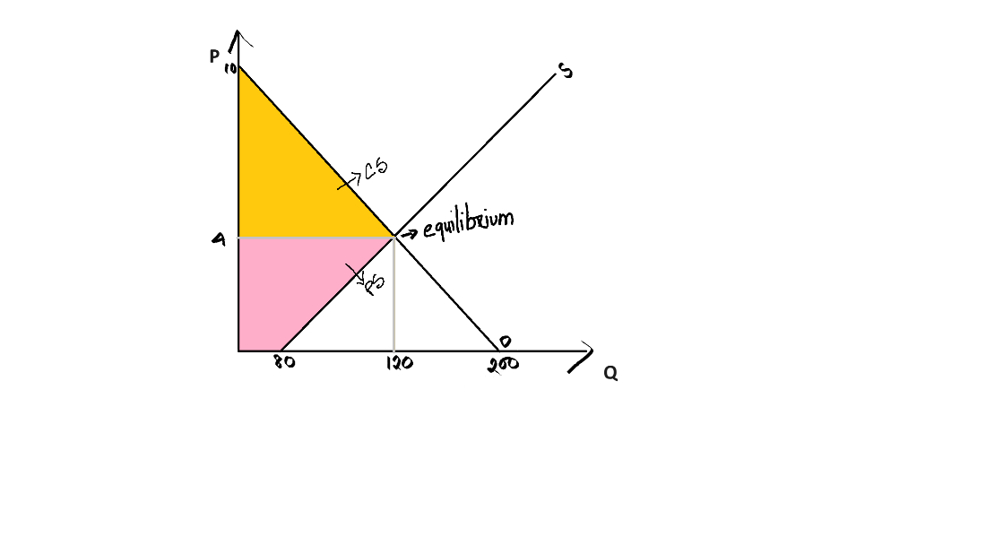

1. Find the equilibrium price and quantity and the value of consumer and producer surplus.

Ans. Solving the demand and supply function gives the equilibrium price and quantity:

Setting Qd =Qs, we get 200 – 20P=80+10P

After solving for P, P=4

Substitute the equilibrium price, P, in either demand or supply function for equilibrium quantity, Q=80+10(4) =120

So, the equilibrium price in the market for memes is $4 and the equilibrium quantity is 120 units.

The consumer surplus is the area of the yellow triangle:

CS= ½*120* (10-4) = $ 360

The producer surplus is the area of the pink trapezium:

PS=½*(120+80) *4= $ 400

1. There's a sudden increase in the cost of production for memes in Meme-Land. This could happen due to a rise in the price of internet bandwidth, which is necessary for creating and sharing memes online.

What will happen to the demand and supply of memes in Meme-land? What changes will take place, so the market reaches equilibrium?

Ans. With the leftward shift in the supply curve, the equilibrium price of memes increases. The equilibrium quantity of memes decreases. (Illustrate in a figure)

3. A table representing two products, apples and oranges, along with their respective prices and quantities demanded is given below:

|  |  |  |  |
| --- | --- | --- | --- |
| Apple | | Orange | |
| Price per unit | Quantity | Price per unit | Quantity |
| 2 | 100 | 3 | 150 |
| 2.5 | 90 | 2.8 | 160 |

1. Using the data provided in the table for the months of January and February, calculate the Price Elasticity of Demand (PED) for apples. Comment on the PED.

Ans. PED=0.472 or –0.472, inelastic.

1. Calculate the Cross Price Elasticity of Demand (XED) due to price change in orange. Comment on the XED.

Ans. XED=1.524. Substitutes.

4. Initially, the market for laptops was at equilibrium, with the demand for and supply of laptops balanced. However, due to a sudden increase in remote work and online learning, the consumption of laptops surged. Additionally, technological advancements have led to more efficient manufacturing processes, resulting in an increase in the production of laptops. If the consumption of laptops increased more than the impact of technological advancement, describe the impact of these changes in both demand and supply on the market for laptops.

Ans. D increase. S increase. Equilibrium price and equilibrium quantity increases.